“Process Termination Message System”
A Project Report Submitted in the partial fulfillment of the requirements for the award of the degree of

BACHELOR OF TECHNOLOGY
In

DEPARTMENT OF COMPUTER SCIENCE ENGINEERING

By

K ANUSRI 2520030432

K ANSHU 2520030440

K DHEERAJ 2520030193

B MOHITH 2520030028

Under the Esteemed Guidance of

Dr. V MUNIRAJU
Professor
Department of Computer Science and Engineering




K L (Deemed to be) University DEPARTMENT OF COMPUTER SCIENCE ENGINEERING
&

DEPARTMENT OF COMPUTER SCIENCE AND INFORMATION TECHNOLOGY

Declaration

The Project Report entitled “Process Termination Message System” is a record of Bonafide work of K ANUSRI - 2520030432, K ANSHU - 2520030440, K DHEERAJ - 2520030193, B MOHITH - 2520030028 submitted in
partial fulfillment for the award of B. Tech in Computer Science and Engineering (or) Computer Science and Information Technology to the K L University. The results embodied in this report have not been copied from any other departments/University/Institute.

K ANUSRI 2520030432

K ANSHU 2520030440

K DHEERAJ 2520030193

B MOHITH 2520030028

K L (Deemed to be) University

DEPARTMENT OF COMPUTER SCIENCE ENGINEERING

CERTIFICATE

This is to certify that the mini project based report entitled “Process Termination Message System” is a bonafide work done and submitted by K ANUSRI - 2520030432, K ANSHU - 2520030440, K DHEERAJ - 2520030193, B MOHITH - 2520030028
in partial fulfillment of the requirements for the award of the degree of BACHELOR OF TECHNOLOGY in Department of Computer Science Engineering, K L (Deemed to be University), during the academic year 2026-2027.

Signature of the Guide

Signature of the Course Coordinator Signature of the HOD

ACKNOWLEDGEMENT
The success in this project would not have been possible but for the timely help and guidance rendered by many people. Our wish to express my sincere thanks to all those who has assisted us in one way or the other for the completion of my project.

Our greatest appreciation to my Course Coordinator Dr. K. Anusha, and my guide Dr. K. Anusha, Department of Computer Science which cannot be expressed in words for his/her tremendous support, encouragement and guidance for this project.

We express our gratitude to Dr. P Venkateshwara Rao (CSE), Head of the Department for Computer Science Engineering for providing us with adequate facilities, ways and means by which we are able to complete this project-based Lab.

We thank all the members of teaching and non-teaching staff members, and also who have assisted me directly or indirectly for successful completion of this project. Finally, I sincerely thank my parents, friends and classmates for their kind help and cooperation during my work.

K ANUSRI 2520030432

K ANSHU 2520030440

K DHEERAJ 2520030193

B MOHITH 2520030028
Abstract

In Linux, a parent process must collect information about a terminated child to determine how and why it ended. Without this step, terminated children remain as zombie processes and waste system resources. This project, the Process Termination Message System, is a Linux-based C program that creates child processes with fork(), lets each one run a task and terminate, and then reports exactly how every child ended, whether normally through exit() or abnormally through a signal.

The system was developed in two stages. The first version creates three children: two terminate normally with exit statuses 10 and 20, while the third runs in a loop until the parent sends it SIGKILL. The parent collects every child with wait() and uses WIFEXITED(), WEXITSTATUS(), WIFSIGNALED() and WTERMSIG() to print the PID, termination type, exit status or signal number. The final version extends this into an interactive monitor: the user selects 3 to 100 children, each child is tracked through the states PENDING, STARTED, PROCESSING, TERMINATING and TERMINATED in shared memory created with mmap(), and a menu allows the user to query a process by PID, display a status table, send SIGKILL to a chosen PID and print a termination report.

The parent collects children without blocking the menu by using waitpid() with WNOHANG, and a final wait() loop guarantees that every child is reaped before the program exits, so no zombie processes remain. The project was built and tested on Ubuntu using GCC, and it gives a clear, practical demonstration of process creation, synchronization, signal-based termination and process-lifecycle management in Linux.

Index

S. No. | Chapter | Topics / Subtopics | Page No.
 | Acknowledgement |  | i
 | Abstract |  | ii
1 | Introduction |  | 8–9
 |  | 1.1 Background of the Project | 8
 |  | 1.2 Problem Statement | 8
 |  | 1.3 Scope of the Project | 8
 |  | 1.4 Objectives of the Project | 9
 |  | 1.5 Importance of the Application | 9
 |  | 1.6 Target Users / Audience | 9
2 | OS Concepts and Background Study |  | 10–11
 |  | 2.1 Operating System Concepts Related to the Project | 10
 |  | 2.2 Existing Methods / Algorithms | 10
 |  | 2.3 Proposed Approach | 11
 |  | 2.4 Advantages of the Proposed Approach | 11
3 | System Requirements |  | 12–13
 |  | 3.1 Hardware Requirements | 12
 |  | 3.2 Software Requirements | 12
 |  | 3.3 Operating System Environment – Ubuntu / WSL
 |  | 3.4 Development Tools and Compilers | 12
4 | Technology and Tools Used |  | 14–15
 |  | 4.1 C / C++ Programming | 14
 |  | 4.2 GCC Compiler | 14
 |  | 4.3 Linux System Calls | 14
 |  | 4.4 POSIX Threads / Synchronization | 14
 |  | 4.5 Linux Commands and Utilities | 15
 |  | 4.6 Other Tools / Libraries Used | 15
5 | System Architecture and Design |  | 16–19
 |  | 5.1 Overall System Architecture | 16
 |  | 5.2 System Workflow | 16
 |  | 5.3 Flowchart / Data Flow | 17
 |  | 5.4 Module Description | 18
 |  | 5.5 Input and Output Design | 19
6 | Implementation |  | 20–31
 |  | 6.1 Module-wise Implementation | 20
 |  | 6.2 Algorithm / Pseudocode | 20
 |  | 6.3 Core C / C++ Implementation | 21
 |  | 6.4 Linux System Calls / APIs Used | 30
 |  | 6.5 Process / Thread Implementation | 30
 |  | 6.6 IPC / Synchronization Implementation | 30
 |  | 6.7 Memory Management Implementation | 31
 |  | 6.8 Optional User Interface Implementation | 31
7 | Execution and Demonstration |  | 32–39
 |  | 7.1 Compilation in Ubuntu | 32
 |  | 7.2 Execution Commands | 32
 |  | 7.3 Sample Inputs and Outputs | 32
 |  | 7.4 Screenshots of Execution | 33
 |  | 7.5 Demonstration of OS Concepts | 38
8 | Conclusion |  | 40–41
 |  | 8.1 Summary of the Project | 40
 |  | 8.2 Objectives Achieved | 40
 |  | 8.3 Results Achieved | 40
 |  | 8.4 Skills and Learning Outcomes | 41
9 | References |  | 42
 |  | 9.1 Books | 42
 |  | 9.2 Research Papers | 42
 |  | 9.3 Linux / GNU Documentation | 42
 |  | 9.4 Online Resources | 42

CHAPTER -1 INTRODUCTION
1.1 Background of the Project
An operating system runs many processes at the same time, and these processes are organised in a parent-child hierarchy. In Linux, a new process is created with the fork() system call; the creator becomes the parent and the new process becomes the child. When a child finishes, the kernel keeps a small record of it (its PID, exit status and the signal that ended it) until the parent asks for that information. A child that has finished but has not yet been collected by its parent is called a zombie process. Zombies hold a process-table entry and a PID, so a parent that creates many children and never collects them gradually wastes system resources.
This project, the Process Termination Message System, was developed for the course Operating Systems and Systems Programming (25CS2104E), 2026-27, Term-I (Section 08, Team 10). It is a Linux-based C program in which a parent process creates several child processes, lets some terminate normally and others terminate abnormally through a signal, collects every child with wait() / waitpid(), and prints a clear termination message for each one.
1.2 Problem Statement
When multiple child processes are created in a Linux system, the parent needs a reliable mechanism to detect their termination and to extract meaningful information about how they ended. Without proper handling, terminated children remain as zombie processes and waste system resources.
The first version of the project (Review 2) solved this for a fixed set of three children. That design has two limitations: the number of processes cannot be changed, and the parent blocks inside wait() so the user cannot inspect or control the processes while they run. The final version (Review 3) therefore extends the system so that the user can select the number of child processes and monitor their execution and termination, using their actual PIDs, through an interactive menu.
1.3 Scope of the Project
- Creation of a user-selected number of child processes (3 to 100) using fork().
- Tracking of each child's PID and life-cycle state (PENDING, STARTED, PROCESSING, TERMINATING, TERMINATED) in shared memory.
- Normal termination through exit() with a distinct exit status for every child.
- Abnormal termination through SIGKILL, sent automatically to Child-3 and, on request, to any PID chosen by the user.
- Collection of terminated children with waitpid() and wait(), and analysis of their status with WIFEXITED(), WEXITSTATUS(), WIFSIGNALED() and WTERMSIG().
- A menu-driven, text-based interface to query a PID, show all statuses, send SIGKILL and display the termination report.
- Out of scope: graphical interfaces, networked or multi-machine monitoring, and handling of signals other than SIGKILL.

1.4 Objectives of the Project
- Create multiple child processes using the fork() system call.
- Detect and monitor the termination of child processes.
- Use wait() or waitpid() to collect and analyse child-process termination status.
- Identify normal and abnormal termination and prevent child processes from becoming zombies.
- Allow the user to select 3 to 100 children and track each child's PID and state (final version).
- Provide PID-based status checking, an all-process status table and a complete termination report (final version).

1.5 Importance of the Application
Process management is a core responsibility of every operating system, and correct handling of child termination is a basic requirement for reliable system software such as shells, servers and daemons. The project turns these abstract ideas into a working program in which the effect of every system call can be seen on the terminal. It shows why a parent must reap its children, how an exit status differs from a terminating signal, and how a parent can keep monitoring its children without blocking.
1.6 Target Users / Audience
- Students of Operating Systems and Systems Programming who want a hands-on demonstration of fork(), wait(), waitpid(), signals and zombie prevention.
- Faculty and evaluators reviewing process-management concepts in a Linux environment.
- Beginners in Linux system programming who need a small, readable reference for process life-cycle handling.

CHAPTER -2 OS CONCEPTS AND BACKGROUND STUDY
2.1 Operating System Concepts Related to the Project
The project is built on the following process-management concepts of the Linux operating system.
Concept | Explanation and role in the project
Process creation | fork() duplicates the calling process. The parent receives the child's PID; the child receives 0. The project forks one child per requested process.
Parent-child relationship | Every child keeps a link to its parent. Only the parent can collect the termination status of its children, which is why the parent performs all reporting.
Process termination | A child ends normally by calling exit(status), or abnormally when a signal such as SIGKILL terminates it.
Exit status | The value passed to exit(). The parent reads it with WEXITSTATUS(); in this project Child-k exits with 10 x k.
Signals | kill() delivers a signal to a process. SIGKILL (signal 9) cannot be caught or ignored, so it is used to produce a reliable abnormal termination.
Synchronization | wait() and waitpid() make the parent synchronize with the end of its children. WNOHANG lets waitpid() return immediately so the menu is never blocked.
Zombie process | A terminated child whose status has not been collected. Reaping every child with waitpid() / wait() prevents zombies.
Process states | The final version models a life cycle of PENDING, STARTED, PROCESSING, TERMINATING and TERMINATED for each child.
Shared memory | mmap() with MAP_SHARED | MAP_ANONYMOUS creates memory visible to the parent and all children, so a child can publish its state and the parent can read it.

2.2 Existing Methods / Algorithms
The conventional ways in which a parent handles the termination of its children are summarised below.
- Blocking wait(): the parent calls wait() in a loop and sleeps until a child terminates. It is simple and reaps every child, but the parent can do nothing else in the meantime.
- waitpid() on a specific PID: the parent waits for one particular child. It gives control over the order of collection but still blocks.
- Non-blocking waitpid() with WNOHANG: the parent polls and returns immediately when no child has finished, so it can continue other work.
- SIGCHLD handling: the kernel notifies the parent with SIGCHLD when a child changes state, and a handler reaps the child.

The first implementation of this project (termination.c, Review 2) uses the blocking wait() method with a fixed set of three children. The parent creates Child-1 (exit status 10, 2-second task), Child-2 (exit status 20, 4-second task) and Child-3 (endless loop). After 3 seconds the parent sends SIGKILL to Child-3 and then collects all three children with a wait() loop. This version correctly demonstrates normal and abnormal termination, but its number of processes is fixed, it has no user interaction and the parent is unavailable while it waits.
2.3 Proposed Approach
The final implementation (final_termination.c, Review 3) keeps the same termination concepts and removes the limitations of the first version:
- The user chooses the number of children (3 to 100), and the children are created in a loop with fork().
- A ProcessInfo record per child (PID, child number, state, exit status, signal number) is stored in shared memory created with mmap(), and each child updates its own state as it runs.
- The parent collects finished children with waitpid(-1, &status, WNOHANG) inside reap_children(), so it never blocks and the menu stays responsive.
- A menu lets the user query a PID, view a status table, send SIGKILL to any PID and print a termination report; the menu stays available after all children have terminated.
- On exit, a final wait() loop collects any remaining child so that no zombie is left, and the shared memory is released with munmap().

2.4 Advantages of the Proposed Approach
Aspect | Review 2 (termination.c) | Review 3 (final_termination.c)
Number of children | Fixed at 3 | User-selected, 3 to 100
Collection method | Blocking wait() | Non-blocking waitpid(WNOHANG) plus final wait()
Process information | Local variables only | ProcessInfo table in shared memory
Process states | Not tracked | PENDING, STARTED, PROCESSING, TERMINATING, TERMINATED
User interaction | None | Menu: query PID, status table, SIGKILL a PID, report
Abnormal termination | SIGKILL to Child-3 only | SIGKILL to Child-3 automatically and to any PID on request
Zombie prevention | wait() loop | waitpid() polling plus final wait() loop

CHAPTER -3 SYSTEM REQUIREMENTS
3.1 Hardware Requirements
The program is small and uses very little memory (a table of at most 100 records). The following configuration is sufficient to compile and run it comfortably.
Component | Requirement
Processor | Dual-core processor, 1.5 GHz or higher
Memory (RAM) | 2 GB or more (4 GB recommended when running Ubuntu under Windows)
Storage | At least 1 GB of free disk space for the Linux environment, compiler and source files
Display and input | Standard monitor, keyboard and mouse

3.2 Software Requirements
Software | Purpose
Ubuntu Linux (native or under WSL) | Operating-system environment for development and testing
GCC (GNU Compiler Collection) | Compiles the C source file
Nano or any text editor (VS Code) | Writing and editing termination.c and final_termination.c
Linux terminal / shell | Compiling, running and observing the program
GDB (GNU Debugger) | Debugging when required
Git and GitHub | Version control and repository management

3.3 Operating System Environment - Ubuntu / WSL
The project was developed and tested on Ubuntu Linux. The terminal prompts in the execution screenshots (for example k_anusri@DESKTOP-TM20BAQ) show an Ubuntu shell running on a Windows computer through the Windows Subsystem for Linux (WSL). WSL provides a real Linux kernel interface, so fork(), waitpid(), kill(), signals and mmap() behave exactly as they do on a native Ubuntu installation. The program uses only POSIX and Linux system calls and therefore runs unchanged on native Ubuntu.
3.4 Development Tools and Compilers
- GCC: compiles the source with the command gcc termination.c -o termination.
- GNU Nano: used in the Ubuntu terminal to create and save the source file (Ctrl+O to save, Ctrl+X to exit).
- Terminal: used for compilation, execution and entering the menu choices.
- GDB: available for stepping through the program and inspecting processes when debugging is required.
- Git and GitHub: the source code and documents are maintained in the project repository.

CHAPTER -4 TECHNOLOGY AND TOOLS USED
4.1 C / C++ Programming
The project is written in the C programming language, which gives direct access to Linux system calls. C was chosen because the Linux process API (fork, wait, waitpid, kill, mmap) is defined as C functions and macros, and because the language makes the behaviour of each call visible without any runtime layer in between. The program uses structures (ProcessInfo), an enumeration (ProcessState), pointers to shared memory and standard control structures.
4.2 GCC Compiler
The source file is compiled with the GNU C compiler:
gcc termination.c -o termination
The final version defines _GNU_SOURCE at the top of the file so that the Linux-specific features required by MAP_ANONYMOUS are available. Compilation completed without errors or warnings reported in the terminal, as shown in Chapter 7.
4.3 Linux System Calls
System call / macro | Purpose in the project
fork() | Creates each child process.
getpid() | Returns the PID of the calling process for display and for recording in shared memory.
exit() | Terminates a child normally with an exit status.
wait() | Collects remaining children (Review 2 report loop, Review 3 final loop).
waitpid() | Collects terminated children; with WNOHANG it returns immediately.
kill() | Sends SIGKILL to a child process.
sleep() | Simulates work in the children and spaces the parent's actions.
mmap() / munmap() | Create and release the shared-memory table of ProcessInfo records.
WIFEXITED(), WEXITSTATUS() | Detect normal termination and read the exit status.
WIFSIGNALED(), WTERMSIG() | Detect signal termination and read the signal number.

4.4 POSIX Threads / Synchronization
The project does not use POSIX threads. It is a multi-process program, and synchronization is achieved at the process level: the parent synchronizes with its children through wait() / waitpid(), which also deliver each child's termination status. Data sharing between the processes is done through anonymous shared memory (Section 6.6) rather than through thread-level primitives such as mutexes.
4.5 Linux Commands and Utilities
Command | Use
nano termination.c | Create, edit and save the source file
ls, ls -l, cd, find | Locate and verify the source file in the Ubuntu home directory
gcc termination.c -o termination | Compile the program
./termination | Run the program
gdb ./termination | Debug the program when required
git add / commit / push | Maintain the project repository on GitHub

4.6 Other Tools / Libraries Used
Header | Provides
<stdio.h> | printf(), scanf(), perror(), getchar(), fflush()
<stdlib.h> | exit()
<unistd.h> | fork(), getpid(), sleep()
<sys/wait.h> | wait(), waitpid(), WNOHANG and the WIF* / W* status macros
<signal.h> | kill() and SIGKILL
<sys/mman.h> | mmap(), munmap() and the PROT_ / MAP_ constants (final version)

GitHub hosts the project repository at https://github.com/kanusri-tmj/Jarvis-kernel_OSSP. No third-party libraries are required; only the C standard library and the Linux system-call interface are used.

CHAPTER -5 SYSTEM ARCHITECTURE AND DESIGN
5.1 Overall System Architecture
The system consists of one parent process and N child processes. The parent owns the user interface and is the only process that collects termination status. Each child performs its simulated task and updates its own record in a table held in shared memory. The parent reads this table to answer the user's queries and writes the final exit status or signal number after reaping a child.
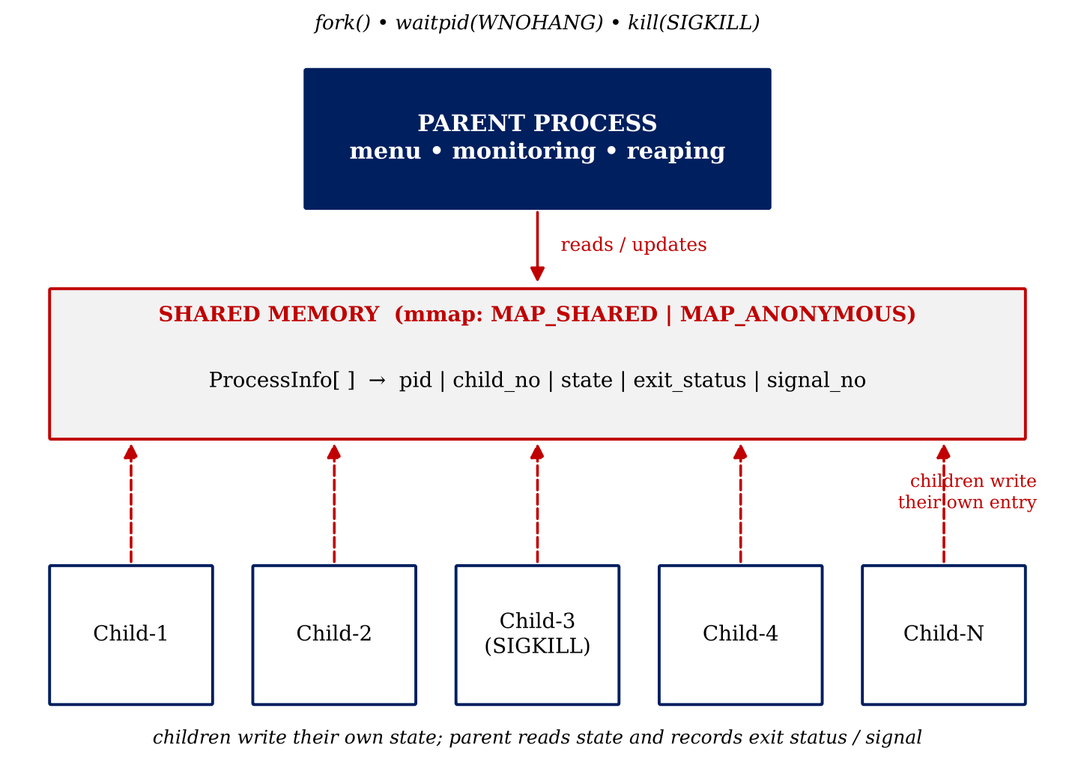
Figure 5.1: Overall system architecture
5.2 System Workflow
- Start the parent process and display its PID.
- Read the number of children (3 to 100) and reject invalid input.
- Allocate the ProcessInfo table with mmap() and initialise every entry to PENDING.
- Create the children with fork(). Each child stores its PID, moves to STARTED and then PROCESSING, and prints its progress once per second.
- After one second the parent sends SIGKILL to Child-3 to demonstrate abnormal termination.
- Each remaining child finishes its task, moves to TERMINATING and calls exit(10 x child number).
- The parent repeatedly calls reap_children(), which uses waitpid(-1, &status, WNOHANG) to collect finished children and record WEXITSTATUS() or WTERMSIG().
- The user works with the menu until option 5 is chosen.
- The parent collects any remaining children with wait(), prints the closing message and releases the shared memory with munmap().

The state of a child changes as shown in Figure 5.2.
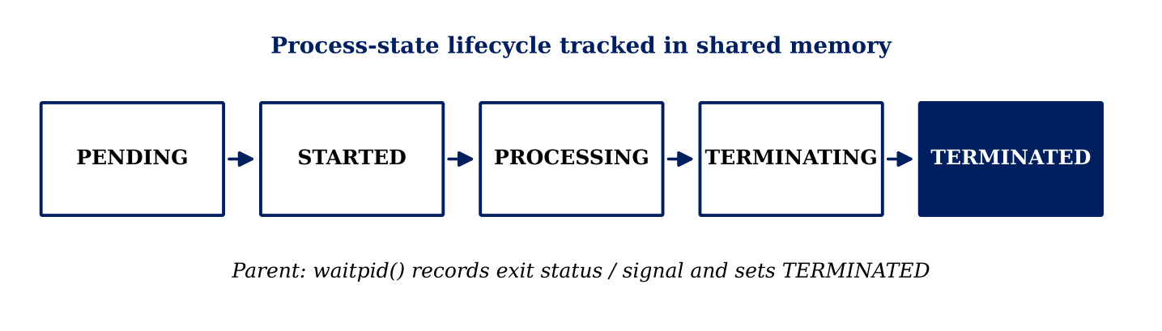
Figure 5.2: Process-state life cycle
State | Meaning
PENDING | Entry initialised but the child has not started.
STARTED | The child has been created and has recorded its PID.
PROCESSING | The child is performing its assigned work.
TERMINATING | The child is completing its task, or the parent has sent SIGKILL.
TERMINATED | The parent has collected the termination status with waitpid().

5.3 Flowchart / Data Flow
Figure 5.3 shows the control flow of the final program. The data that flows between the processes is the ProcessInfo table: children write their state, and the parent reads the table and writes the exit status or signal number when it reaps a child.
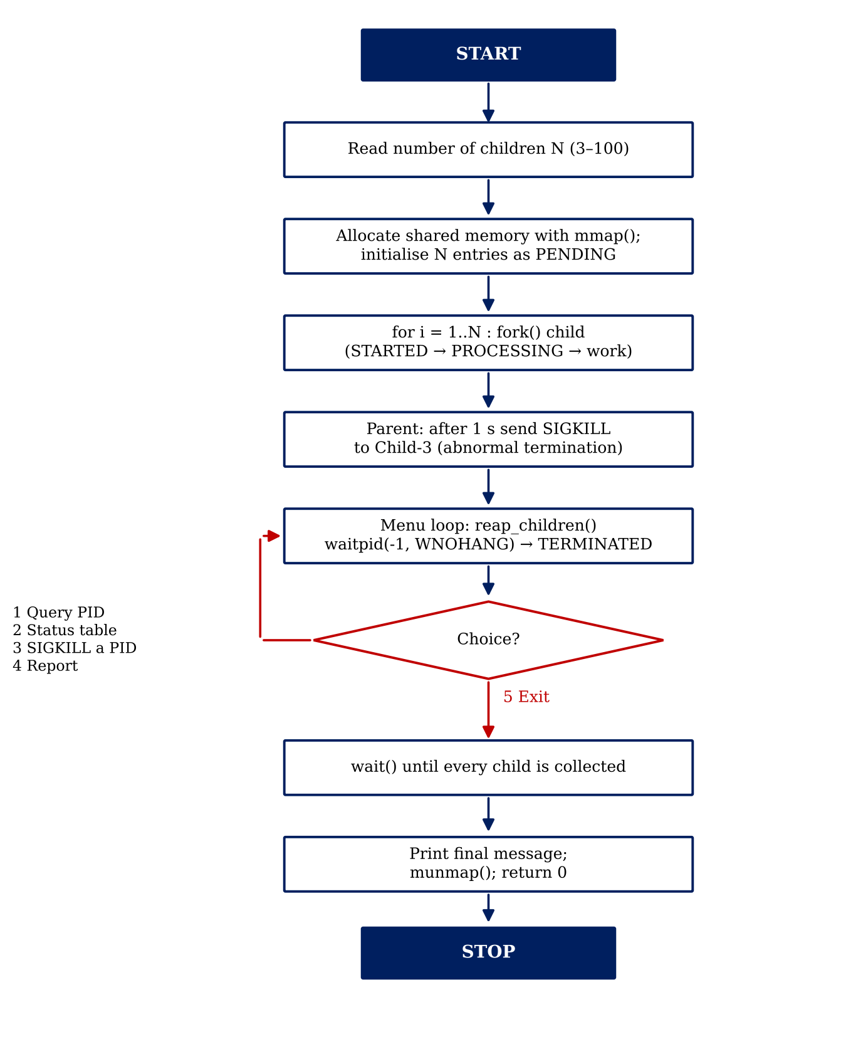
Figure 5.3: Flowchart of the final program
5.4 Module Description
Module / function | Description
main() - initialisation | Reads the child count, creates the shared table and initialises every entry.
main() - process creation | Forks the children; each child runs its processing loop and exits normally.
main() - control loop | Reaps children, displays the menu and dispatches the user's choice.
reap_children() | Collects finished children with waitpid(WNOHANG) and records exit status or signal.
find_index_by_pid() | Maps an actual PID to its entry in the table.
query_pid() | Menu option 1: shows the state and termination details of one PID.
show_all() | Menu option 2: prints the status table of all children.
terminate_child() | Menu option 3: sends SIGKILL to a chosen child.
Termination report | Menu option 4: prints the termination type, exit status or signal for every child.
state_name() / show_process() | Helpers that convert a state to text and print one process record.

The work was divided among the team members as follows.
Reg. No. | Name | Contribution
2520030432 | K Anusri | Process creation using fork() and overall project integration
2520030440 | K Anshu | Normal child-process termination and exit-status handling
2520030193 | K Dheeraj | Abnormal termination and signal handling
2520030028 | B Mohith | Testing, output analysis, documentation and GitHub repository management

5.5 Input and Output Design
Input | Description | Validation
Number of children | Integer entered at start-up | Must be from 3 to 100; otherwise the program prints a message and stops
Menu choice | Integer 1 to 5 | Non-numeric or unknown values print 'Invalid choice.'
PID | Actual PID of a child, entered for options 1 and 3 | Non-numeric input is rejected; a PID that is not a child prints 'is not a child process of this system'

Output | Content
Start-up banner | Program title and the parent's PID
Child messages | '[Child-k] PID=... started', 'Processing... t/n' and 'Completing task normally'
Status table | Child number, PID and state of every child
PID query | Child number, PID, state and, if terminated, NORMAL with exit status or ABNORMAL with the signal number
Termination report | Child PID, termination type and exit status or signal for every child
Closing message | 'All child processes collected. No zombie processes exist.'

CHAPTER -6 IMPLEMENTATION
6.1 Module-wise Implementation
The implementation was completed in two stages, corresponding to the second and third project reviews. Stage 1 (termination.c) is a 97-line program that fixes the termination logic. Stage 2 (final_termination.c) is a 422-line program that adds the shared process table, the process states and the interactive menu. Both stages are listed in Section 6.3.
Stage | Source file | Review | Main features
1 | termination.c | Review 2 | Three children (exit 10, exit 20, SIGKILL), blocking wait() loop, termination report
2 | final_termination.c | Review 3 (final) | 3 to 100 children, mmap() shared table, five process states, waitpid(WNOHANG), menu with four operations

6.2 Algorithm / Pseudocode
Stage 1 - fixed three children:
START
print parent PID
child1 = fork(); if child1 is the child: sleep(2); exit(10)
child2 = fork(); if child2 is the child: sleep(4); exit(20)
child3 = fork(); if child3 is the child: loop forever (print, sleep 1)
sleep(3)
kill(child3, SIGKILL)
while (pid = wait(&status)) > 0
if WIFEXITED(status) print NORMAL and WEXITSTATUS(status)
else if WIFSIGNALED(status) print ABNORMAL and WTERMSIG(status)
print "all children collected, no zombies"
END
Stage 2 - final version:
START
read N; if N < 3 or N > 100 then report error and stop
info = mmap(shared, N records); initialise every record to PENDING
for i = 0 .. N-1
pid = fork()
if pid == 0 (child):
info[i].pid = getpid(); state = STARTED; print "started"
state = PROCESSING
repeat (5 + i mod 3) times: print progress; sleep(1)
state = TERMINATING; print "completing normally"
exit(10 * (i + 1))
info[i].pid = pid (parent)
sleep(1); state[2] = TERMINATING; kill(info[2].pid, SIGKILL)
loop
reap_children()
show menu and read choice
1: read PID; reap_children(); print record of that PID
2: reap_children(); print status table
3: read PID; if valid and not terminated: state = TERMINATING; kill(pid, SIGKILL)
4: reap_children(); print termination report
5: leave loop
while wait(NULL) > 0 do nothing (collect remaining children)
print final message; munmap(); return 0
END
reap_children():
while (pid = waitpid(-1, &status, WNOHANG)) > 0
find record of pid; state = TERMINATED
if WIFEXITED(status) exit_status = WEXITSTATUS(status); signal_no = 0
if WIFSIGNALED(status) signal_no = WTERMSIG(status); exit_status = 0
6.3 Core C / C++ Implementation
Stage 1: termination.c (Review 2)
The complete source of the first version is given below. The three children are created one after another; the parent sends SIGKILL to Child-3 after three seconds and then collects all children in a wait() loop.
#include <stdio.h>
#include <stdlib.h>
#include <unistd.h>
#include <sys/wait.h>
#include <signal.h>
int main()
{
pid_t child1, child2, child3;
pid_t terminated_pid;
int status;
printf("=========================================\n");
printf("PROCESS TERMINATION MESSAGE SYSTEM\n");
printf("Parent PID : %d\n", getpid());
printf("=========================================\n\n");
/* Child 1 : Normal Termination */
child1 = fork();
if(child1 == 0)
{
printf("[Child-1] PID=%d started\n", getpid());
sleep(2);
printf("[Child-1] Completing task normally\n");
exit(10);
}
/* Child 2 : Normal Termination */
child2 = fork();
if(child2 == 0)
{
printf("[Child-2] PID=%d started\n", getpid());
sleep(4);
printf("[Child-2] Completing task normally\n");
exit(20);
}
/* Child 3 : Abnormal Termination */
child3 = fork();
if(child3 == 0)
{
printf("[Child-3] PID=%d started\n", getpid());
while(1)
{
printf("[Child-3] Running...\n");
sleep(1);
}
}
sleep(3);
printf("\nParent sending SIGKILL to Child-3 (PID=%d)\n\n",
child3);
kill(child3, SIGKILL);
printf("=========== TERMINATION REPORT ===========\n");
while((terminated_pid = wait(&status)) > 0)
{
printf("\nChild PID : %d\n", terminated_pid);
if(WIFEXITED(status))
{
printf("Termination Type : NORMAL\n");
printf("Exit Status : %d\n",
WEXITSTATUS(status));
}
else if(WIFSIGNALED(status))
{
printf("Termination Type : ABNORMAL\n");
printf("Killed By Signal : %d\n",
WTERMSIG(status));
}
}
printf("\n=========================================\n");
printf("All child processes collected.\n");
printf("No zombie processes exist.\n");
printf("Project Execution Completed.\n");
printf("=========================================\n");
return 0;
}
Stage 2: final_termination.c (Review 3, final version)
The final source is presented function by function. First, the header files, the process-state enumeration, the ProcessInfo structure and the two global variables.
#define _GNU_SOURCE
#include <stdio.h>
#include <stdlib.h>
#include <unistd.h>
#include <sys/wait.h>
#include <signal.h>
#include <sys/mman.h>
#define MAX_CHILDREN 100
typedef enum
{
PENDING,
STARTED,
PROCESSING,
TERMINATING,
TERMINATED
} ProcessState;
typedef struct
{
pid_t pid;
int child_no;
ProcessState state;
int exit_status;
int signal_no;
} ProcessInfo;
ProcessInfo *info;
int child_count;
state_name() converts a state to its text, find_index_by_pid() searches the table for an actual PID, and show_process() prints one record, choosing NORMAL or ABNORMAL from the stored signal number.
const char *state_name(ProcessState state)
{
switch(state)
{
case PENDING:
return "PENDING";
case STARTED:
return "STARTED";
case PROCESSING:
return "PROCESSING";
case TERMINATING:
return "TERMINATING";
case TERMINATED:
return "TERMINATED";
default:
return "UNKNOWN";
}
}
int find_index_by_pid(pid_t pid)
{
for(int i = 0; i < child_count; i++)
{
if(info[i].pid == pid)
return i;
}
return -1;
}
void show_process(ProcessInfo *p)
{
printf("\nChild-%d\n", p->child_no);
printf("PID : %d\n", p->pid);
printf("Status : %s\n", state_name(p->state));
if(p->state == TERMINATED)
{
if(p->signal_no != 0)
{
printf("Termination : ABNORMAL\n");
printf("Killed By Signal : %d\n", p->signal_no);
}
else
{
printf("Termination : NORMAL\n");
printf("Exit Status : %d\n", p->exit_status);
}
}
}
reap_children() is the core of the termination handling. It calls waitpid(-1, &status, WNOHANG) repeatedly; WNOHANG makes the call return at once when no child has finished, so the menu is never blocked. For each collected child it marks the record TERMINATED and stores the exit status or the terminating signal.
void reap_children(void)
{
int status;
pid_t pid;
while((pid = waitpid(-1, &status, WNOHANG)) > 0)
{
int index = find_index_by_pid(pid);
if(index == -1)
continue;
info[index].state = TERMINATED;
if(WIFEXITED(status))
{
info[index].exit_status = WEXITSTATUS(status);
info[index].signal_no = 0;
}
else if(WIFSIGNALED(status))
{
info[index].signal_no = WTERMSIG(status);
info[index].exit_status = 0;
}
}
}
query_pid() implements menu option 1 and show_all() implements menu option 2. Both call reap_children() first so that the information displayed is current.
void query_pid(void)
{
pid_t pid;
printf("\nEnter PID number: ");
if(scanf("%d", &pid) != 1)
{
while(getchar() != '\n');
printf("Invalid PID.\n");
return;
}
reap_children();
int index = find_index_by_pid(pid);
if(index == -1)
{
printf("PID %d is not a child process of this system.\n", pid);
return;
}
show_process(&info[index]);
}
void show_all(void)
{
reap_children();
printf("\n================ PROCESS STATUS TABLE ================\n");
printf("%-10s %-10s %-15s\n",
"Child",
"PID",
"Status");
printf("-------------------------------------------------------\n");
for(int i = 0; i < child_count; i++)
{
printf("%-10d %-10d %-15s\n",
i + 1,
info[i].pid,
state_name(info[i].state));
}
printf("=======================================================\n");
}
terminate_child() implements menu option 3. It validates the PID, refuses to signal a child that has already terminated, marks the child TERMINATING and sends SIGKILL with kill().
void terminate_child(void)
{
pid_t pid;
printf("\nEnter PID to terminate: ");
if(scanf("%d", &pid) != 1)
{
while(getchar() != '\n');
printf("Invalid PID.\n");
return;
}
reap_children();
int index = find_index_by_pid(pid);
if(index == -1)
{
printf("PID %d is not a child process of this system.\n", pid);
return;
}
if(info[index].state == TERMINATED)
{
printf("PID %d is already terminated.\n", pid);
return;
}
info[index].state = TERMINATING;
printf("Parent sending SIGKILL to Child-%d (PID=%d)\n",
info[index].child_no,
pid);
if(kill(pid, SIGKILL) == -1)
perror("kill");
}
The start of main() prints the banner, reads and validates the number of children, creates the shared table with mmap() and initialises every record to PENDING.
int main(void)
{
printf("=========================================\n");
printf("PROCESS TERMINATION MESSAGE SYSTEM\n");
printf("Parent PID : %d\n", getpid());
printf("=========================================\n\n");
printf("Enter number of child processes (3-%d): ",
MAX_CHILDREN);
if(scanf("%d", &child_count) != 1 ||
child_count < 3 ||
child_count > MAX_CHILDREN)
{
printf("Invalid number. Please enter a value from 3 to %d.\n",
MAX_CHILDREN);
return 1;
}
info = mmap(NULL,
sizeof(ProcessInfo) * child_count,
PROT_READ | PROT_WRITE,
MAP_SHARED | MAP_ANONYMOUS,
-1,
0);
if(info == MAP_FAILED)
{
perror("mmap");
return 1;
}
for(int i = 0; i < child_count; i++)
{
info[i].pid = 0;
info[i].child_no = i + 1;
info[i].state = PENDING;
info[i].exit_status = 0;
info[i].signal_no = 0;
}
printf("\nScheduling and creating %d child processes...\n\n",
child_count);
The fork loop creates the children. Each child records its PID, passes through STARTED and PROCESSING, prints its progress for 5 + (i mod 3) seconds and finally calls exit(10 x child number). The parent stores each child's PID returned by fork().
for(int i = 0; i < child_count; i++)
{
pid_t pid = fork();
if(pid < 0)
{
perror("fork");
return 1;
}
if(pid == 0)
{
info[i].pid = getpid();
info[i].state = STARTED;
printf("[Child-%d] PID=%d started\n",
i + 1,
getpid());
fflush(stdout);
info[i].state = PROCESSING;
int work_time = 5 + (i % 3);
for(int t = 1; t <= work_time; t++)
{
printf("[Child-%d] Processing... %d/%d\n",
i + 1,
t,
work_time);
fflush(stdout);
sleep(1);
}
info[i].state = TERMINATING;
printf("[Child-%d] Completing task normally\n",
i + 1);
fflush(stdout);
exit(10 * (i + 1));
}
info[i].pid = pid;
}
One second after the children have started, the parent terminates Child-3 with SIGKILL to demonstrate abnormal termination.
sleep(1);
if(child_count >= 3)
{
info[2].state = TERMINATING;
printf("\nParent sending SIGKILL to Child-3 (PID=%d)\n",
info[2].pid);
fflush(stdout);
kill(info[2].pid, SIGKILL);
}
The menu loop reaps children, counts the terminated ones, displays the menu and dispatches the user's choice. Choice 4 prints the termination report.
int choice;
int terminated_count = 0;
while(1)
{
reap_children();
terminated_count = 0;
for(int i = 0; i < child_count; i++)
{
if(info[i].state == TERMINATED)
terminated_count++;
}
printf("\n================ PROCESS MENU ================\n");
printf("1. Query status using PID\n");
printf("2. Show all process statuses\n");
printf("3. Send SIGKILL to a PID\n");
printf("4. Show termination report\n");
printf("5. Exit\n");
printf("==============================================\n");
printf("Enter choice: ");
if(scanf("%d", &choice) != 1)
{
while(getchar() != '\n');
printf("Invalid choice.\n");
continue;
}
if(choice == 1)
{
query_pid();
}
else if(choice == 2)
{
show_all();
}
else if(choice == 3)
{
terminate_child();
}
else if(choice == 4)
{
reap_children();
printf("\n=========== TERMINATION REPORT ===========\n");
for(int i = 0; i < child_count; i++)
{
printf("\nChild PID : %d\n",
info[i].pid);
printf("Termination Type : ");
if(info[i].signal_no != 0)
{
printf("ABNORMAL\n");
printf("Killed By Signal : %d\n",
info[i].signal_no);
}
else if(info[i].state == TERMINATED)
{
printf("NORMAL\n");
printf("Exit Status : %d\n",
info[i].exit_status);
}
else
{
printf("NOT YET TERMINATED\n");
}
}
}
else if(choice == 5)
{
break;
}
else
{
printf("Invalid choice.\n");
}
sleep(1);
}
After the loop ends, the final wait() loop collects any child that is still running, the closing message is printed and the shared memory is released.
while(wait(NULL) > 0);
printf("\n=========================================\n");
printf("All child processes collected.\n");
printf("No zombie processes exist.\n");
printf("Project Execution Completed.\n");
printf("=========================================\n");
munmap(info,
sizeof(ProcessInfo) * child_count);
return 0;
}
6.4 Linux System Calls / APIs Used
API / macro | Where it is used
fork() | Child creation in main() (three calls in Stage 1, one per requested child in Stage 2)
getpid() | Banner, child start message and recording of the child's PID
exit(10 x k) | End of Child-k in the fork loop (exit(10) and exit(20) in Stage 1)
kill(pid, SIGKILL) | Automatic termination of Child-3 and terminate_child()
wait(&status) / wait(NULL) | Stage 1 report loop and the final collection loop of Stage 2
waitpid(-1, &status, WNOHANG) | reap_children()
WIFEXITED(), WEXITSTATUS() | reap_children() (and the Stage 1 report loop)
WIFSIGNALED(), WTERMSIG() | reap_children() (and the Stage 1 report loop)
mmap(), munmap() | Creation and release of the shared ProcessInfo table
sleep() | Simulated work in the children; delay before the parent's SIGKILL

6.5 Process / Thread Implementation
Processes are created in a loop; the child branch (pid == 0) never returns to the loop because it ends with exit(). Each child's workload lasts 5 + (i mod 3) seconds, so with several children the processes finish at different times and the termination order is not fixed. Child k terminates with exit status 10 x k, which makes every exit status unique and easy to recognise in the output (10, 20, 40, 50 for Children 1, 2, 4 and 5 in the sample run). Child-3 never reaches exit(): the parent terminates it with SIGKILL, so it is reported as ABNORMAL with signal 9. No threads are used.
Note: the operating system keeps only the low 8 bits of an exit status. Because the status is 10 x k, a child numbered 26 or higher would report a value reduced modulo 256 (for example 260 would appear as 4). The sample runs use small child counts and are not affected.
6.6 IPC / Synchronization Implementation
Communication between the children and the parent uses anonymous shared memory. The table is created with mmap(NULL, sizeof(ProcessInfo) x N, PROT_READ | PROT_WRITE, MAP_SHARED | MAP_ANONYMOUS, -1, 0) before the first fork(), so every child inherits the same mapping and its writes (PID, STARTED, PROCESSING, TERMINATING) are immediately visible to the parent. An ordinary malloc()'d table would not work because each child would modify only its own private copy.
Synchronization with termination is done with waitpid(). The parent alone writes the TERMINATED state, the exit status and the signal number, and it does so only after the kernel has reported that the child has ended. Each child writes only its own record, and the only field that both sides can write is the state: the parent sets TERMINATING immediately before sending SIGKILL, so any overlap is harmless and no lock is required.
6.7 Memory Management Implementation
The memory for the process table is requested from the kernel with mmap() and its size depends on the number of children entered by the user (at most 100 records). The return value is checked against MAP_FAILED, and every record is initialised before the first fork(). When the program finishes, munmap() releases the region. Because the fork loop and the menu use only fixed-size local variables, there is no other dynamic memory to manage.
6.8 Optional User Interface Implementation
The user interface is a text menu displayed in the terminal. After the children have been created, the following menu is shown repeatedly until the user selects option 5:
================ PROCESS MENU ================
1. Query status using PID
2. Show all process statuses
3. Send SIGKILL to a PID
4. Show termination report
5. Exit
==============================================
Invalid numbers, non-numeric input and unknown PIDs are rejected with a message, and the menu continues to be available after all children have terminated.

CHAPTER -7 EXECUTION AND DEMONSTRATION
7.1 Compilation in Ubuntu
The source file was created with Nano in the Ubuntu terminal (nano termination.c), saved with Ctrl+O and Enter, and closed with Ctrl+X. It was then compiled with GCC:
gcc termination.c -o termination
GCC printed no error message, and the executable termination was produced.
Figure 7.1: Successful compilation and program start
7.2 Execution Commands
./termination
The program was run from the Ubuntu terminal. In the final version the program first asks for the number of child processes; the demonstrated test used 5 children.
7.3 Sample Inputs and Outputs
Review 2 (termination.c): no input is required. The run produced the following results:
Process | PID | Termination type | Result
Parent | 543 | - | -
Child-1 | 544 | NORMAL | Exit status 10
Child-2 | 545 | NORMAL | Exit status 20
Child-3 | 546 | ABNORMAL | Killed by signal 9 (SIGKILL)

Review 3 (final_termination.c): input was 5 child processes, parent PID 692. After the children had finished, the status table, PID queries and the termination report gave the following verified result:
Child | PID (sample run) | Status | Termination | Result
Child-1 | 700 | TERMINATED | NORMAL | Exit 10
Child-2 | 701 | TERMINATED | NORMAL | Exit 20
Child-3 | 702 | TERMINATED | ABNORMAL | Signal 9
Child-4 | 703 | TERMINATED | NORMAL | Exit 40
Child-5 | 704 | TERMINATED | NORMAL | Exit 50

PIDs are assigned by Linux, so they normally change every time the program is run.
7.4 Screenshots of Execution
Review 2 - termination.c
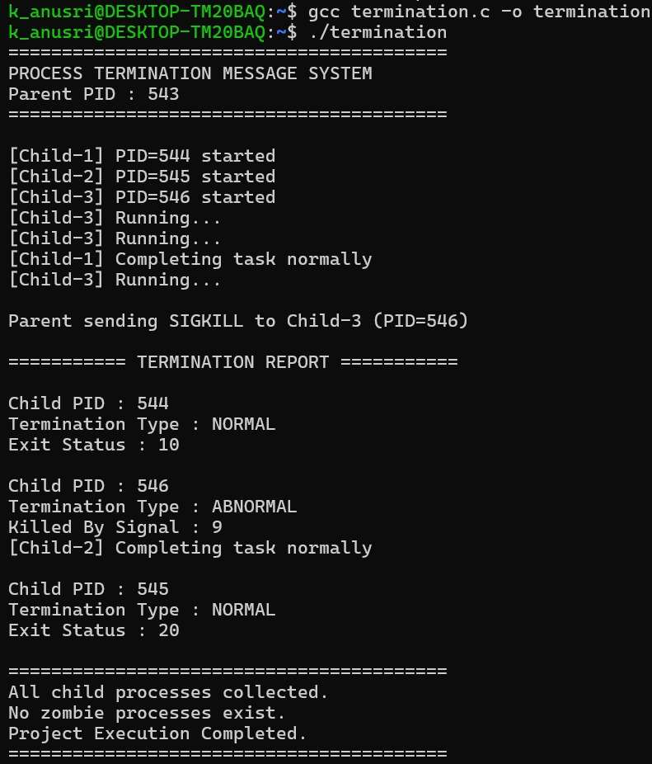
Figure 7.2: Compilation, execution and termination report of termination.c (3 children)
Review 3 - final_termination.c
Creating and saving the source file in Nano:
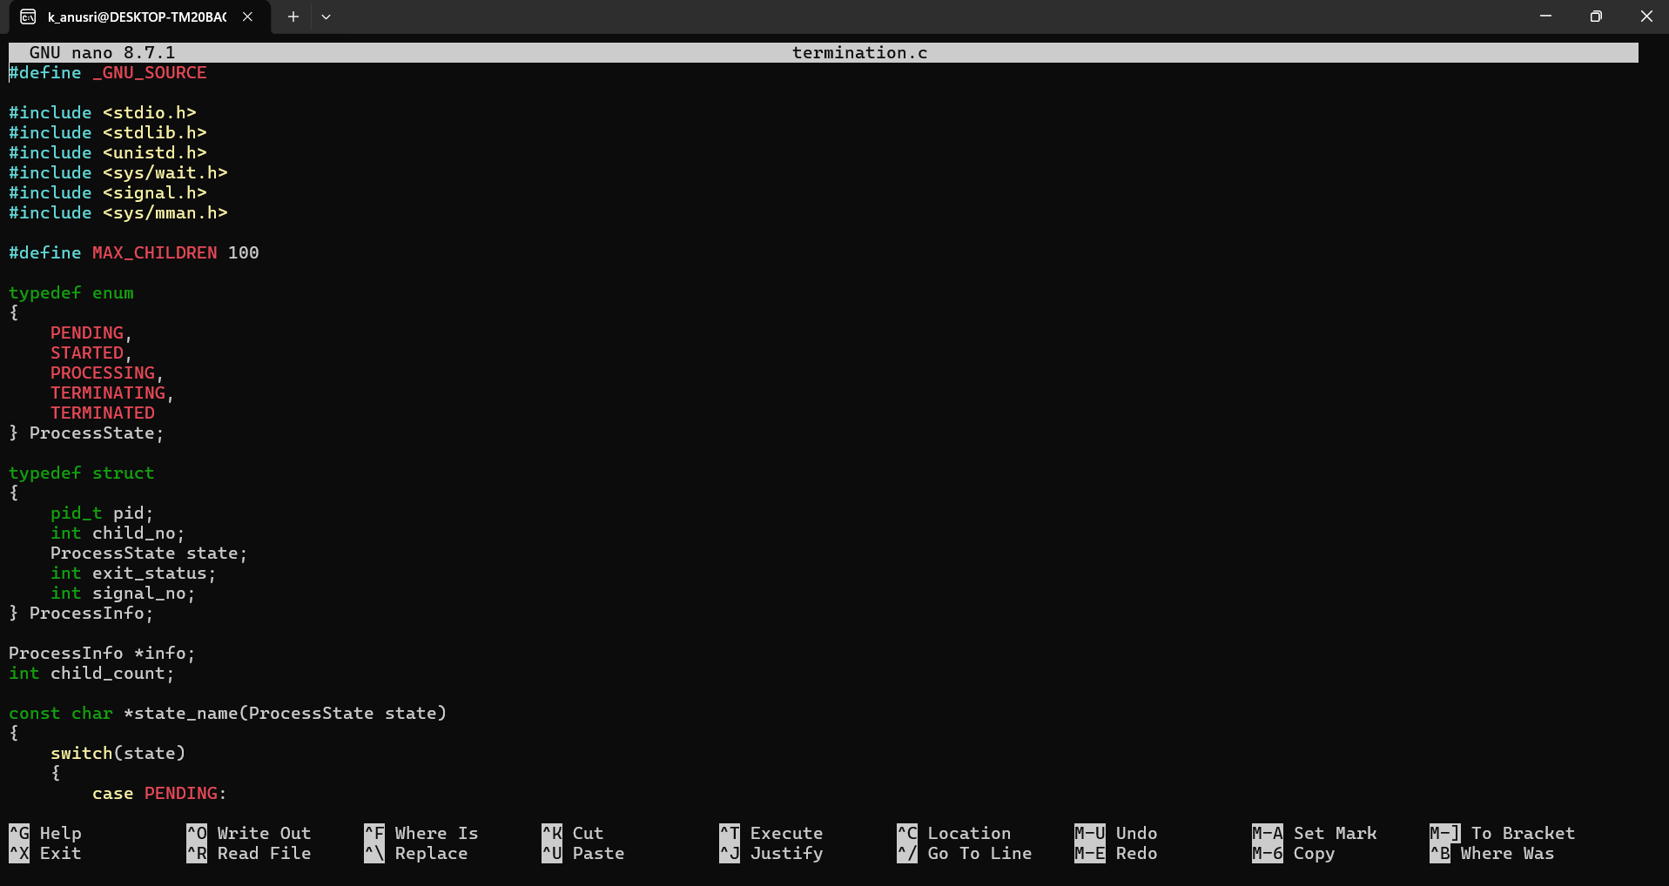
Figure 7.3: final source file open in the Nano editor
Program start: the parent's PID is displayed and the number of child processes (5) is entered. The five children then start, show their PIDs and report their processing progress.
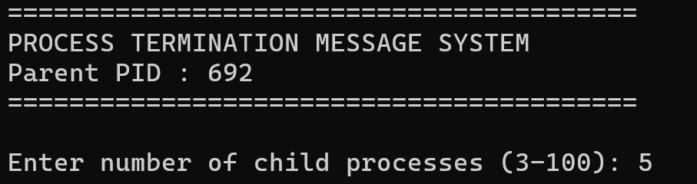
Figure 7.4: Program start, parent PID and input of the number of children
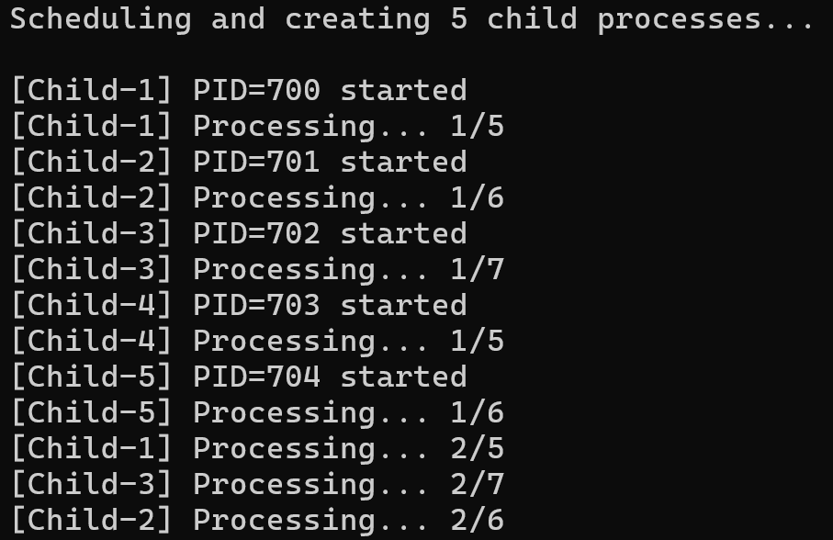
Figure 7.5: Five child processes starting and processing
The parent sends SIGKILL to Child-3, and the interactive process menu is displayed.
Figure 7.6: Parent sending SIGKILL to Child-3 (PID 702)
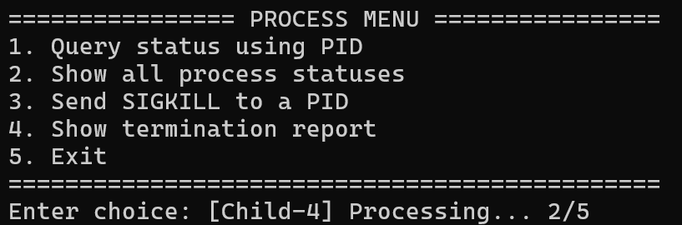
Figure 7.7: Interactive process menu
Menu option 2 displays the status table of all five children.
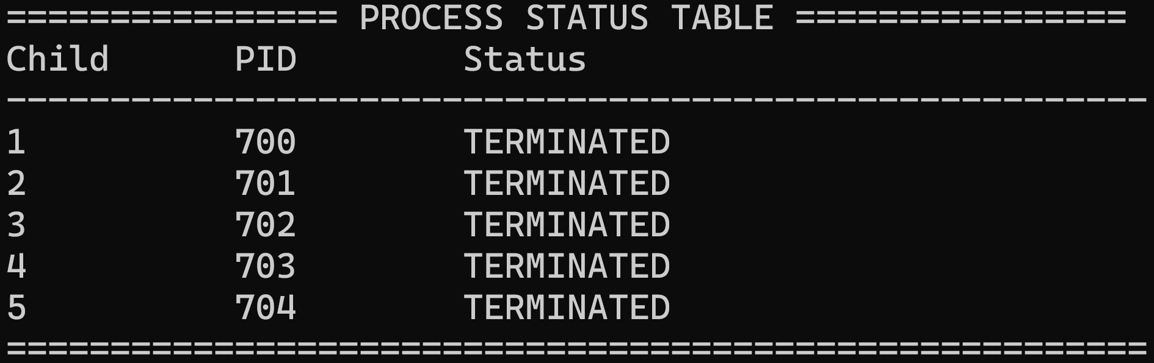
Figure 7.8: Option 2, status table of all children
Menu option 1 was used with each child's actual PID.
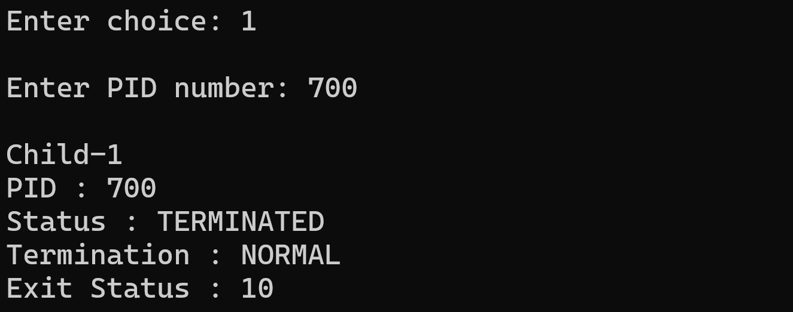
Figure 7.9: Query Child-1 (PID 700), normal termination with exit status
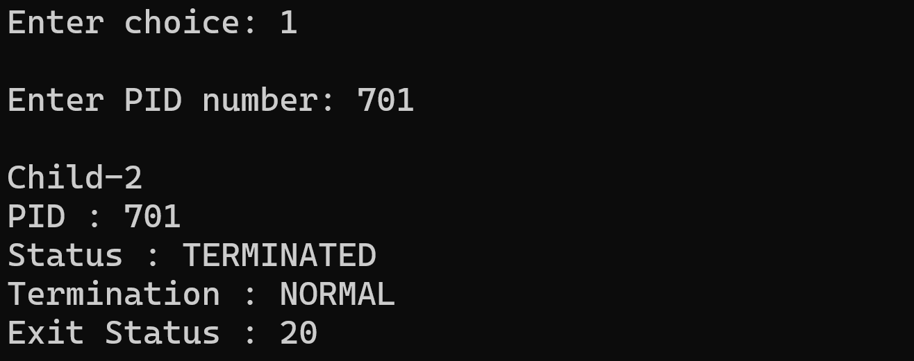
Figure 7.10: Query Child-2, normal termination with exit status
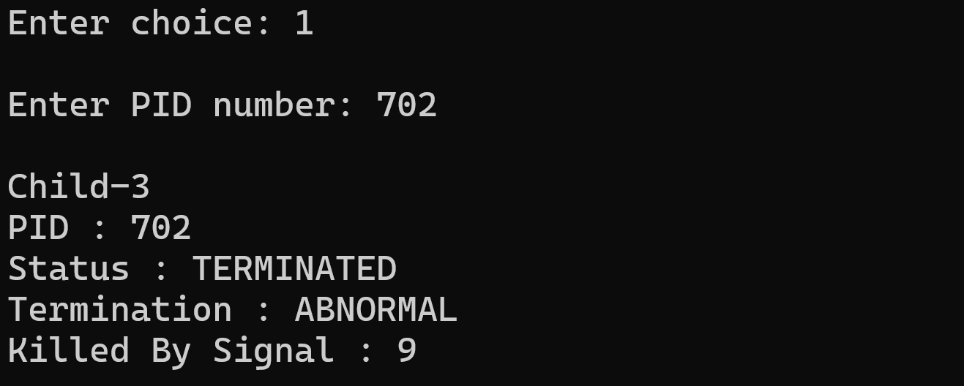
Figure 7.11: Query Child-3 (PID 702), abnormal termination, signal 9
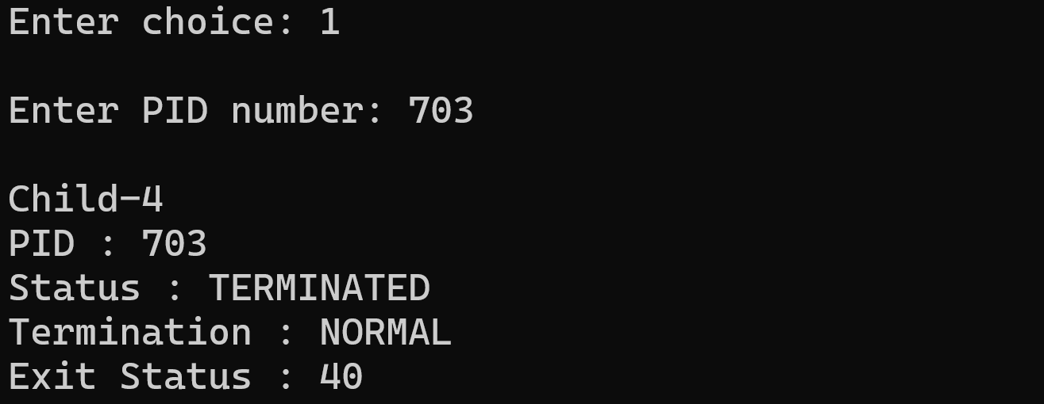
Figure 7.12: Query Child-4, normal termination with exit status
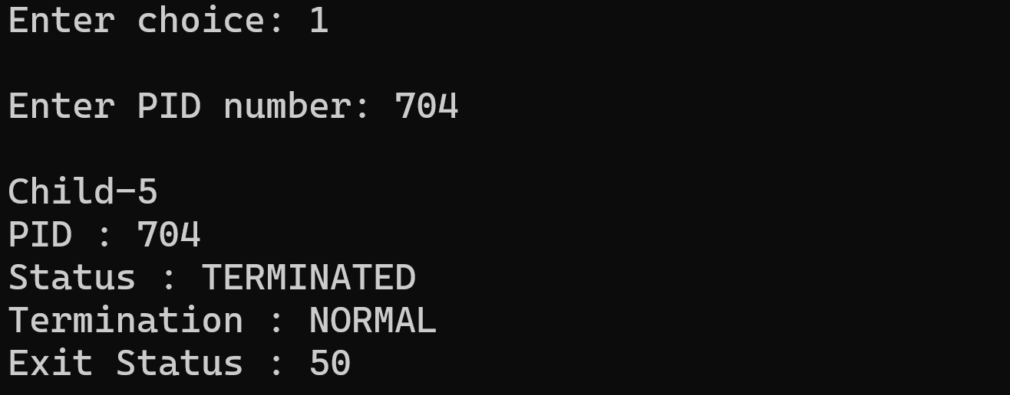
Figure 7.13: Query Child-5, normal termination with exit status
Menu option 4 prints the complete termination report.
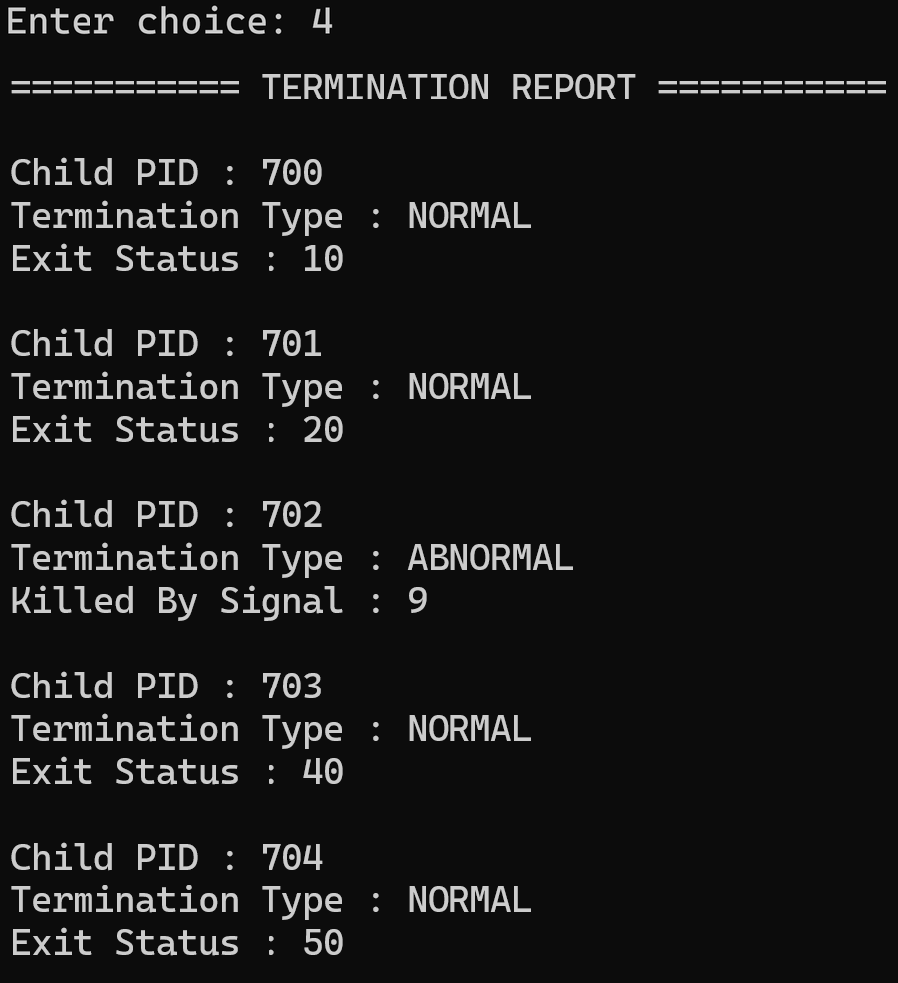
Figure 7.14: Option 4, complete termination report for all five children
Selecting option 5 ends the program; the final message confirms that all children were collected.
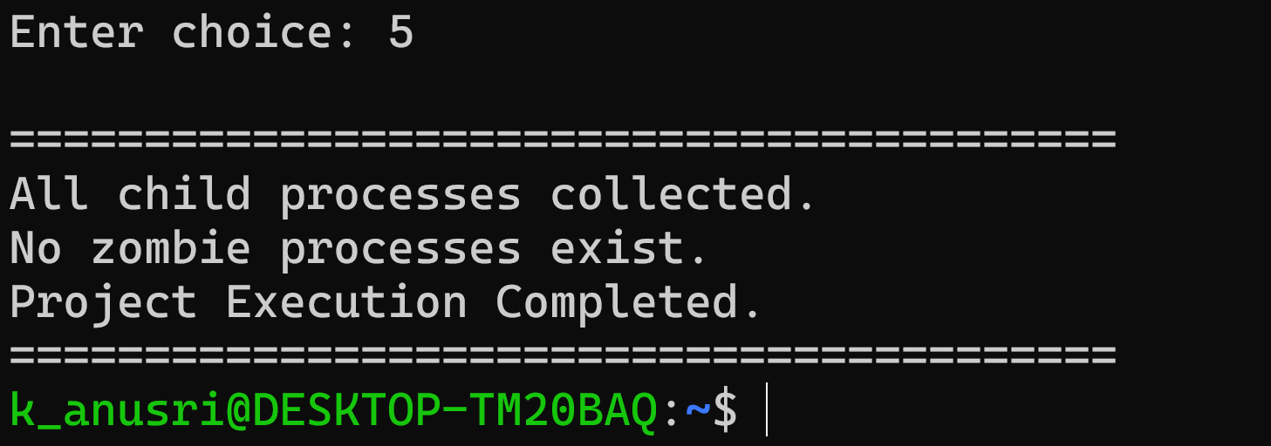
Figure 7.15: Option 5, all children collected and no zombie processes
7.5 Demonstration of OS Concepts
OS concept | Evidence in the execution
Process creation (fork) | Five different child PIDs (700 to 704) appear under parent PID 692.
Parent-child relationship | Only the parent reports the exit status or signal of each child.
Process states | The status table shows each child's state; terminated children are shown as TERMINATED.
Normal termination (exit) | Children 1, 2, 4 and 5 report NORMAL with exit statuses 10, 20, 40 and 50.
Signal-based termination | Child-3 is killed by SIGKILL and is reported ABNORMAL with signal 9.
Synchronization (waitpid, WNOHANG) | The menu responds while children are still running; terminated children are collected without blocking.
Shared memory (mmap) | State changes made by the children are visible to the parent in the status table and PID queries.
Zombie prevention | The closing message confirms that all children were collected and no zombie remains.

CHAPTER -8 CONCLUSION
8.1 Summary of the Project
The Process Termination Message System demonstrates how a Linux parent process creates children with fork(), waits for them, and finds out exactly how each one ended. The first version (Review 2) established the core behaviour with three children: two terminated normally with exit statuses 10 and 20, and one was terminated by SIGKILL, and the parent reported all of them with the wait-status macros. Based on the review feedback, the final version (Review 3) lets the user select 3 to 100 children, tracks each child through five states in shared memory, collects children without blocking using waitpid(WNOHANG), and provides a menu to query a PID, list all statuses, send SIGKILL and print the termination report. In all executions every child was collected and no zombie process remained.
8.2 Objectives Achieved
Objective | Status | Evidence
Create multiple child processes using fork() | Achieved | 3 children in Review 2; 5 children (user-selected 3 to 100) in Review 3
Detect and monitor child termination | Achieved | reap_children(), status table and PID query
Collect status using wait() / waitpid() | Achieved | wait() loop in Review 2; waitpid(WNOHANG) and final wait() in Review 3
Identify normal and abnormal termination | Achieved | NORMAL with exit status; ABNORMAL with signal 9
Prevent zombie processes | Achieved | Closing message after every child was collected
Track PID and process state | Achieved | PENDING, STARTED, PROCESSING, TERMINATING, TERMINATED
Interactive monitoring | Achieved | Menu options 1 to 5 tested

8.3 Results Achieved
- A working Linux application that runs on Ubuntu and compiles without errors using GCC.
- Correct detection of normal termination (Child-1, 2, 4, 5 with exit statuses 10, 20, 40, 50) and signal termination (Child-3, signal 9) in the sample run with 5 children.
- A responsive menu that continues to work after all children have terminated and exits cleanly with option 5.
- Complete termination information for every child in the status table, PID query and termination report.

Limitations observed during the work: the automatic SIGKILL is always sent to Child-3; SIGKILL is the only signal used; exit statuses above 255 are reduced to 8 bits by the operating system; and the final wait() loop waits for any child that is still running if the user exits early. These points can be addressed in future work, for example by allowing the user to choose the signal and the target process at start-up.
8.4 Skills and Learning Outcomes
- Practical use of fork(), exit(), wait(), waitpid(), kill() and the WIF* / W* status macros.
- Understanding of zombie processes and how reaping prevents them.
- Use of signals to produce and recognise abnormal termination.
- Sharing data between processes with mmap() and designing a simple process-state model.
- Compiling, running and debugging C programs in an Ubuntu environment with GCC, Nano, GDB and Git/GitHub.
- Teamwork: dividing a system-programming project into modules, integrating them, testing and documenting the result.

CHAPTER -9 REFERENCES
9.1 Books
- Silberschatz, A., Galvin, P. B. and Gagne, G., Operating System Concepts, Wiley.
- Stevens, W. R. and Rago, S. A., Advanced Programming in the UNIX Environment, Addison-Wesley.
- Kerrisk, M., The Linux Programming Interface, No Starch Press.
- Tanenbaum, A. S. and Bos, H., Modern Operating Systems, Pearson.
- Kernighan, B. W. and Ritchie, D. M., The C Programming Language, Prentice Hall.

9.2 Research Papers
- Ritchie, D. M. and Thompson, K., "The UNIX Time-Sharing System", Communications of the ACM, vol. 17, no. 7, 1974.

9.3 Linux / GNU Documentation
- Linux manual pages: fork(2), wait(2) / waitpid(2), kill(2), exit(3), mmap(2), signal(7).
- GNU C Library Reference Manual - Process Creation and Termination.
- GCC, the GNU Compiler Collection - online documentation.

9.4 Online Resources
- Project repository: https://github.com/kanusri-tmj/Jarvis-kernel_OSSP
- Linux man-pages project: https://man7.org/linux/man-pages/
- GCC online documentation: https://gcc.gnu.org/onlinedocs/
- GNU C Library manual: https://www.gnu.org/software/libc/manual/

